AI - ASSIGNMENT-6.4
NAME:P.BHARGAVI
BATCH:44
2303A52391
Task 1: Student Performance Evaluation System
Scenario:You are building a simple academic management module for a university
system where student performance needs to be evaluated automatically.

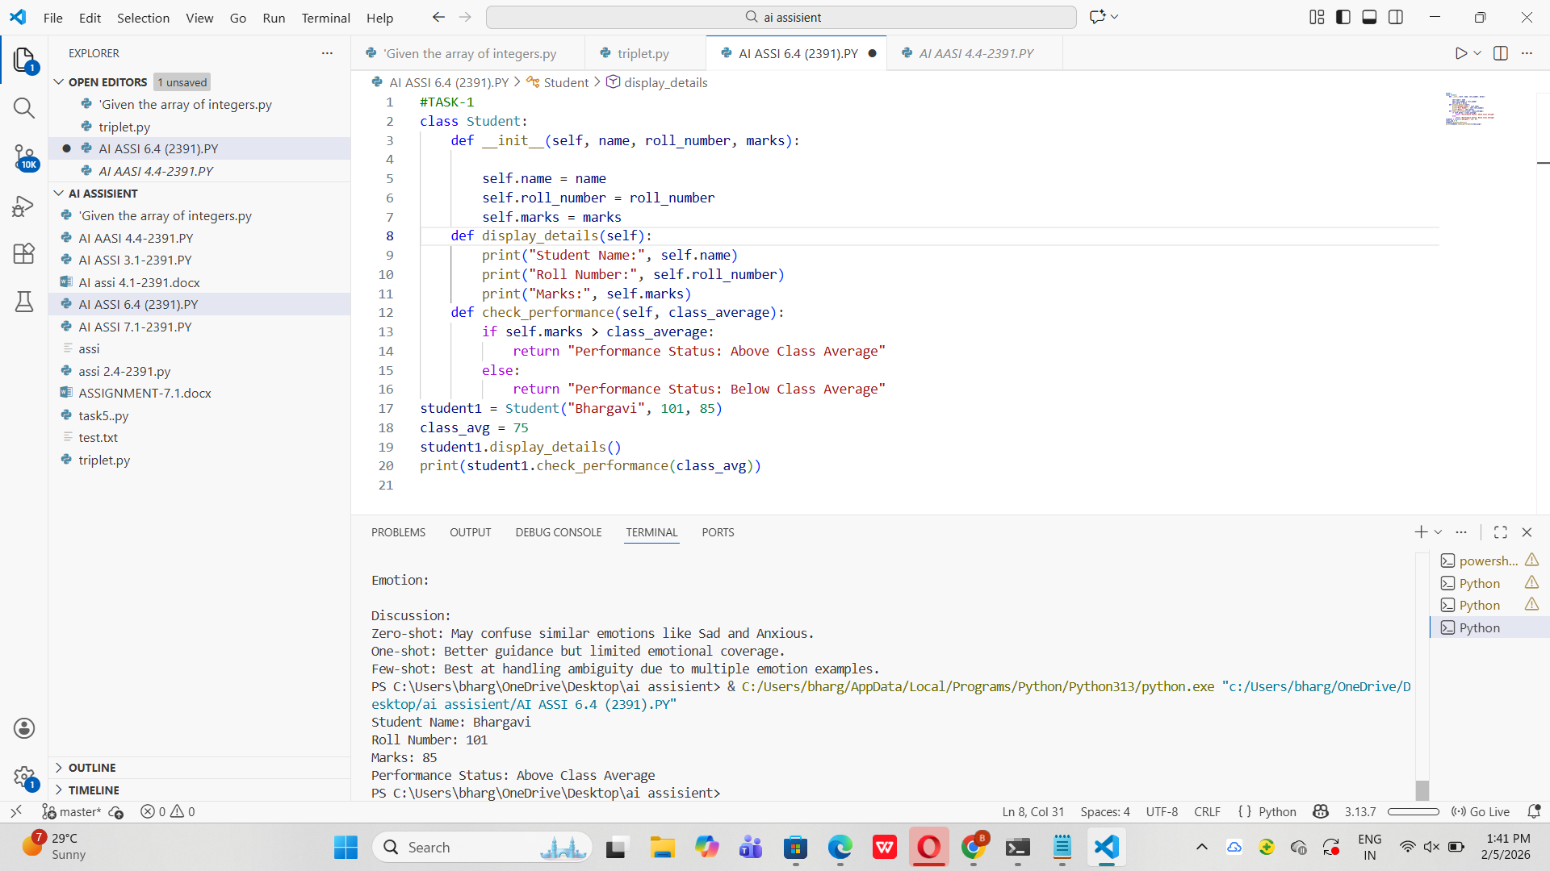

Task 2: Data Processing in a Monitoring System
Scenario:You are working on a basic data monitoring script where sensor readings
are collected as numbers. Only even readings need further processing.

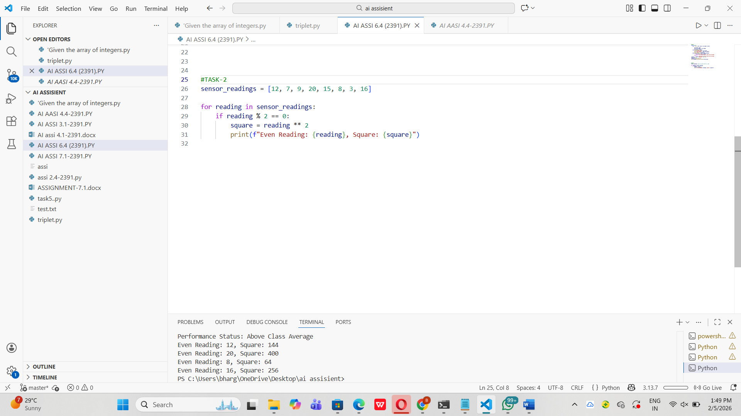

Task 3: Banking Transaction Simulation
Scenario:You are developing a basic banking module that handles deposits and
withdrawals for customers.

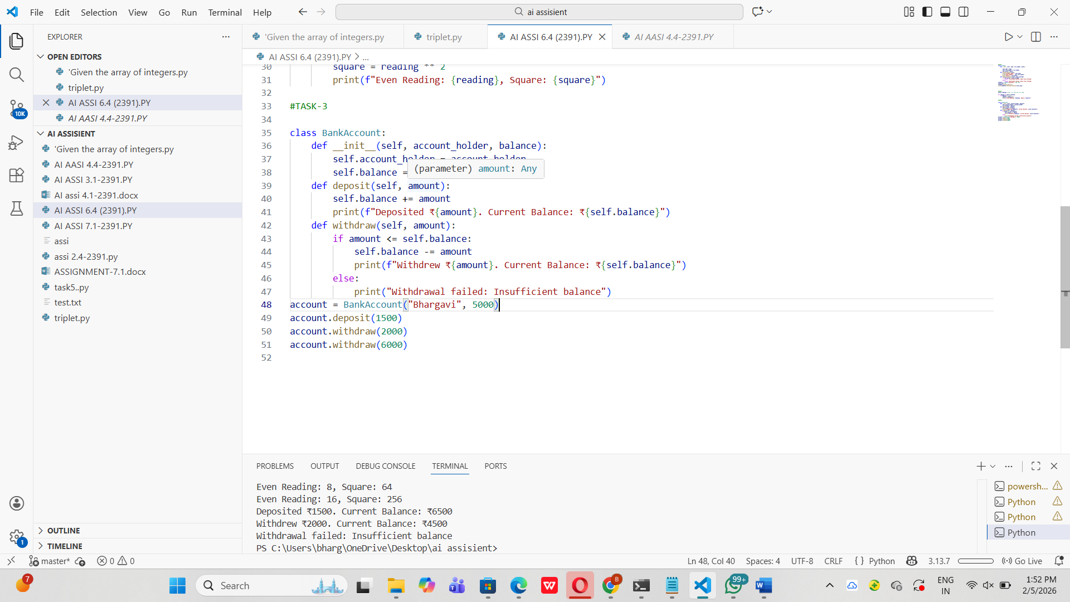

Task 4: Student Scholarship Eligibility Check
Scenario:A university wants to identify students eligible for a merit-basedscholarship based on their scores.

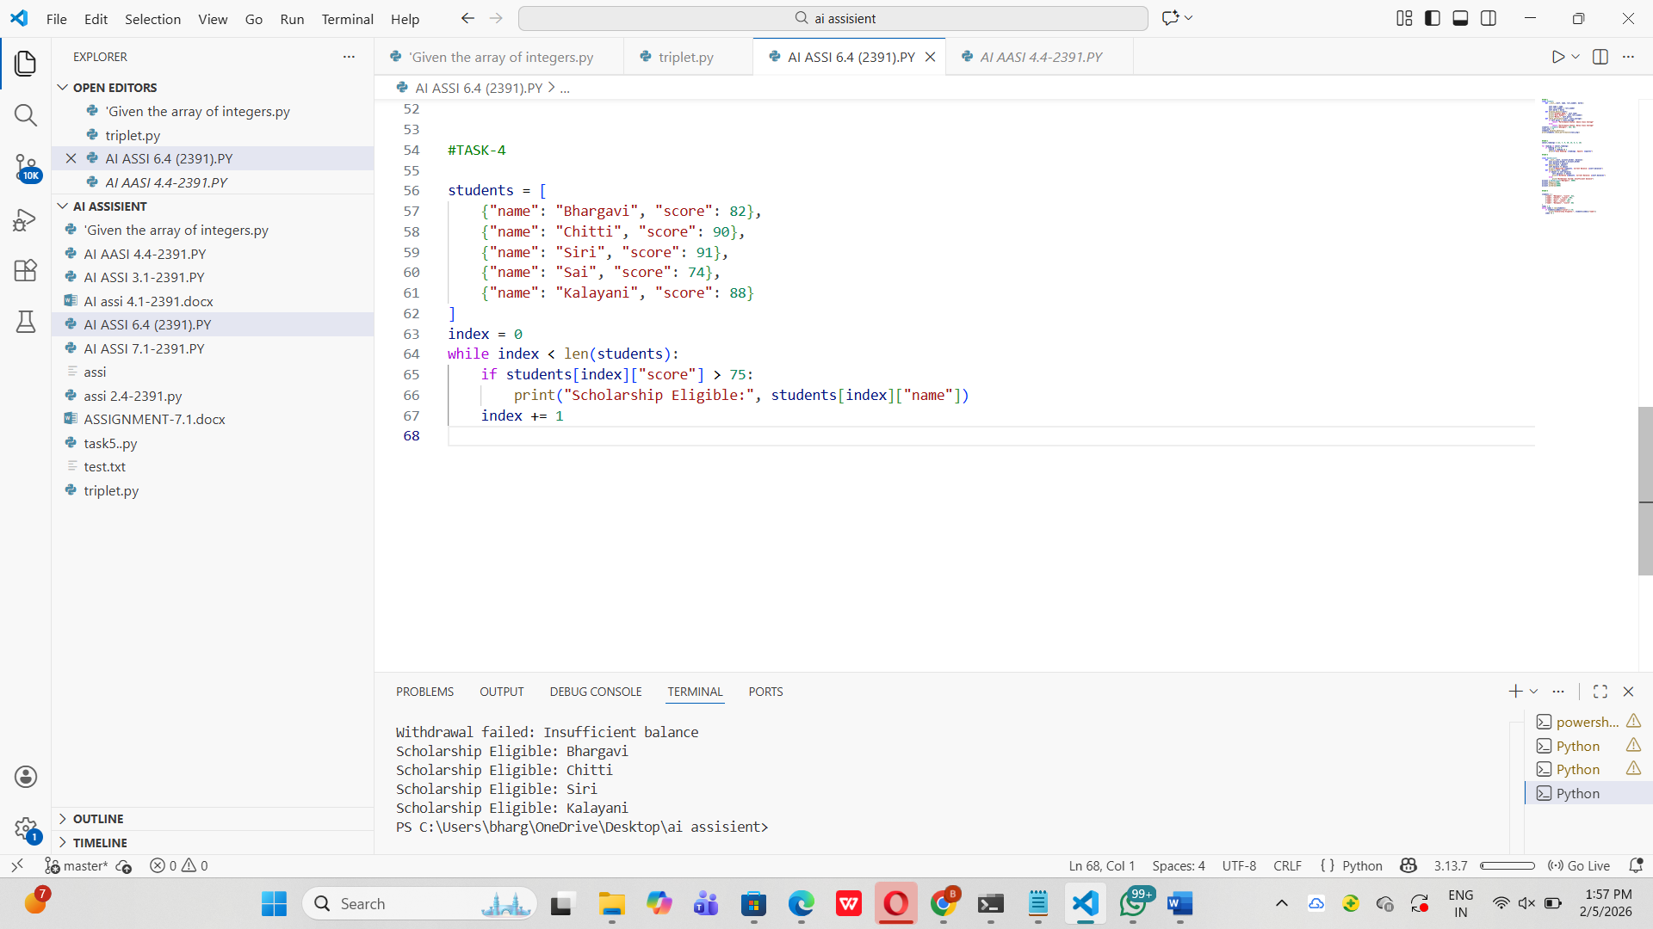

Task 5: Online Shopping Cart Module
Scenario:You are designing a simplified shopping cart system for an e-commerce
website that supports item management and discount calculation
